Azure Storage

Pranav Ram K S

Create a storage

Step 1: Select storage account in dashboard.

Step 2: Select the resource group.

Step 3: Create a Storage account name.

Step 4: Select the region.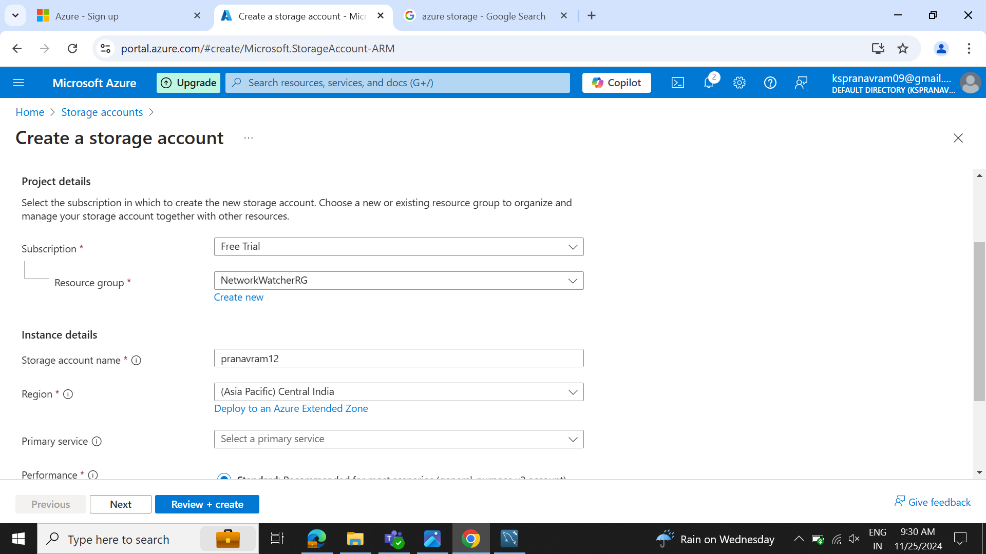

Step 5: Configure the storage according to the requirements.

Step 6: Review the specifications and select create to deploy.

Step 7: After use delete the storage created.

